CodeAlpha Internship Project Report

Sales Performance Analysis using Exploratory Data Analysis (EDA)

Submitted by
John Meddy Roshan
B. Com (Honours)
Christ (Deemed to be University)
Bengaluru, Karnataka

Internship Organization
CodeAlpha

Project Domain
Data Analytics

Tools Used
Python
Pandas
NumPy
Matplotlib
Seaborn
VS Code

Submission Year – 2026

DECLARATION
I hereby declare that the project entitled "Sales Performance Analysis using Exploratory Data Analysis (EDA)" has been completed by me as part of the CodeAlpha Data Analytics Internship.
I confirm that this project is my original work. The analysis, visualizations, and conclusions presented in this report were developed using Python and its data analysis libraries. Wherever external resources, datasets, or references have been used, appropriate acknowledgment has been given.
This project has been prepared solely for academic and internship purposes and has not been submitted previously for any other certification or award.

Name: John Meddy Roshan
Course: B. Com (Honours)
Institution: Christ (Deemed to be University), Bengaluru
Date: 29 July 2026
Signature: John Meddy Roshan

ACKNOWLEDGEMENT
I would like to express my sincere gratitude to CodeAlpha for providing me with the opportunity to work on the Sales Performance Analysis using Exploratory Data Analysis (EDA) project. This internship has provided valuable practical exposure to data analytics and helped me understand how data can be analyzed to support business decision-making.
I would also like to thank my faculty members at Christ (Deemed to be University) for their continuous guidance and encouragement throughout my academic journey.
This project helped me strengthen my knowledge of Python, Pandas, NumPy, Matplotlib, Seaborn, and data visualization techniques. It also improved my analytical thinking, problem-solving ability, and understanding of real-world business data.
Finally, I would like to thank everyone who directly or indirectly supported me in completing this project successfully.
John Meddy Roshan

TABLE OF CONTENTS
Contents | Page No.
Declaration | 2
Acknowledgement | 3
Table of Contents | 4
Introduction | 5
Project Objectives | 6
Dataset Description | 6
Tools & Technologies Used | 7
Methodology | 7
Exploratory Data Analysis | 8
Data Visualizations (Part 1) | 9
Data Visualizations (Part 2) | 10
Data Visualizations (Part 3) | 11
Data Visualizations (Part 4) | 12
Business Insights | 13
Conclusion | 14
References | 15

INTRODUCTION
Sales data analysis is an essential process that helps organizations understand customer purchasing behaviour, identify sales trends, and make informed business decisions. By analyzing historical sales data, businesses can evaluate their performance, improve operational efficiency, and develop effective marketing strategies.
This project focuses on performing Exploratory Data Analysis (EDA) on the Sample Superstore sales dataset using Python. The analysis was carried out with the help of powerful Python libraries such as Pandas, NumPy, Matplotlib, and Seaborn. Various statistical techniques and data visualization methods were used to identify trends, compare sales across different categories and regions, and understand factors affecting business performance.
The project also includes graphical visualizations such as sales distribution, profit distribution, category-wise sales, regional sales, customer segment analysis, monthly sales trends, and correlation analysis. These visualizations help present complex business information in a simple and meaningful manner.
The insights obtained from this analysis can support decision-making by highlighting high-performing products, profitable regions, customer segments, and potential areas for business improvement.

PROJECT OBJECTIVES
The primary objectives of this project are:
- To perform Exploratory Data Analysis (EDA) on the Superstore sales dataset.
- To understand sales and profit trends across different business categories.
- To identify the best-performing products, regions, and customer segments.
- To visualize the data using meaningful charts and graphs.
- To generate business insights that support better decision-making.
- To improve practical knowledge of Python and data analysis libraries.

DATASET DESCRIPTION
The dataset used for this project is the Sample Superstore Dataset, which contains sales transaction records of a retail business. It consists of 9,994 records and 21 columns, including information related to customers, products, sales, profits, discounts, shipping details, and geographical regions.
Some important attributes in the dataset include:
- Order ID
- Order Date
- Customer Name
- Product Name
- Category
- Sub-Category
- Region
- Sales
- Quantity
- Discount
- Profit
This dataset provides valuable information for analyzing sales performance, customer behavior, and profitability across different regions and product categories.

Tools & Technologies Used and Methodology
TOOLS & TECHNOLOGIES USED
The following tools and technologies were used to complete this project:
- Programming Language: Python
- Code Editor: Visual Studio Code (VS Code)
- Libraries Used:
  - Pandas
  - NumPy
  - Matplotlib
  - Seaborn
- Dataset: Sample Superstore Dataset (CSV Format)
- Documentation: Microsoft Word
These tools were selected because they provide efficient data manipulation, visualization, and reporting capabilities required for Exploratory Data Analysis.

METHODOLOGY
The project was completed using the following methodology:
- Imported the required Python libraries.
- Loaded the Superstore dataset into a Pandas DataFrame.
- Examined the dataset structure, data types, and missing values.
- Generated descriptive statistics to understand the data.
- Calculated total sales, total profit, average sales, and average profit.
- Created visualizations to identify sales trends, profit distribution, regional performance, customer segments, product categories, and monthly sales trends.
- Analyzed the visualizations to generate meaningful business insights and conclusions.

EXPLORATORY DATA ANALYSIS
Exploratory Data Analysis (EDA) is the process of examining, summarizing, and visualizing data to identify patterns, relationships, trends, and anomalies before performing advanced analysis or building predictive models.
In this project, the Sample Superstore dataset was analyzed using Python. The dataset contains 9,994 records and 21 columns related to customer information, product details, sales, profit, discounts, shipping information, and geographical regions.
The initial analysis showed that the dataset contained no missing values, making it suitable for direct analysis. Descriptive statistics were generated to understand the distribution of numerical variables such as Sales, Profit, Quantity, and Discount.
The following key statistics were obtained from the dataset:
Metric | Value
Number of Records | 9,994
Number of Columns | 21
Total Sales | 2,297,200.86
Total Profit | 286,397.02
Average Sales | 229.86
Average Profit | 28.66
The data was further explored using different visualizations to understand sales performance across product categories, customer segments, regions, states, and time periods. Correlation analysis was also performed to identify relationships between numerical variables.
The findings from these visualizations helped identify profitable business areas, high-performing regions, and important sales trends that can support better business decision-making.

Data Visualizations (Part 1)

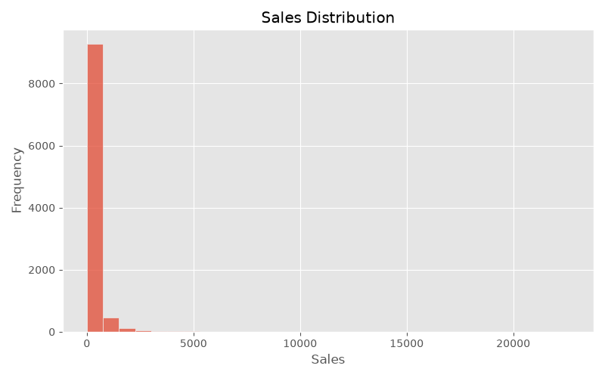

Figure 1: Sales Distribution
Explanation:
The sales distribution graph shows that most transactions involve relatively low sales values, while a small number of transactions have very high sales. This indicates a right-skewed distribution, where a few large orders contribute significantly to the total sales.
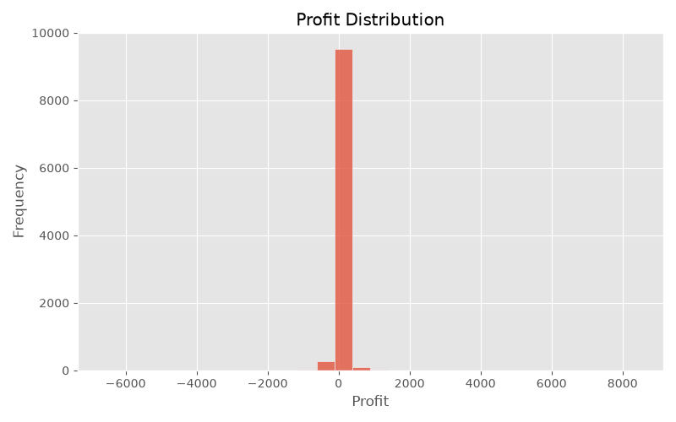
Figure 2: Profit Distribution
Explanation: The profit distribution indicates that most orders generate small profits, while some orders result in losses. A few highly profitable transactions contribute substantially to the overall profit.
Data Visualizations (Part 2)

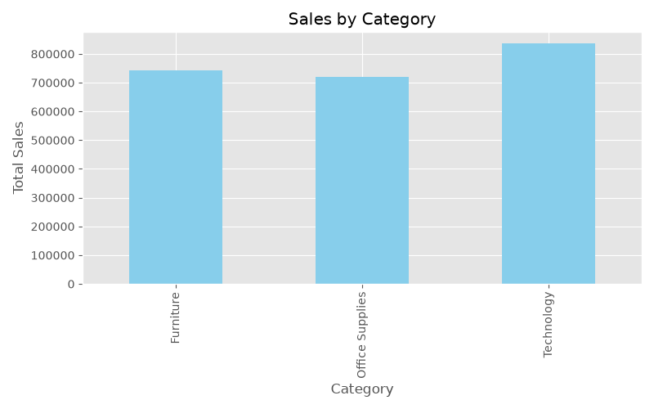
Figure 3: Sales by Category
Explanation:
This chart compares total sales across product categories. It helps identify which categories generate the highest revenue and supports better inventory and marketing decisions.
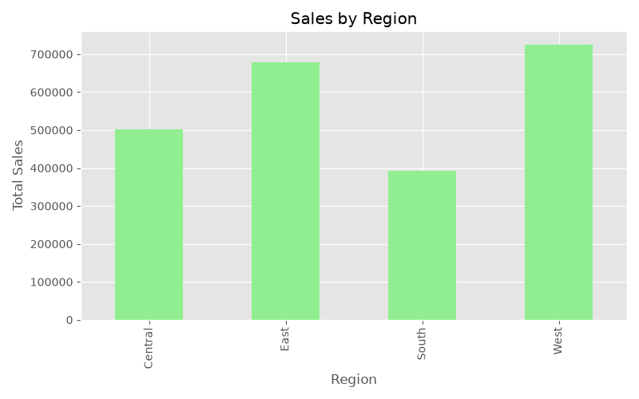
Figure 4: Sales by Region
Explanation: The regional sales chart highlights differences in sales performance across geographical regions. It enables businesses to identify strong markets and regions with growth opportunities.
Data Visualizations (Part 3)

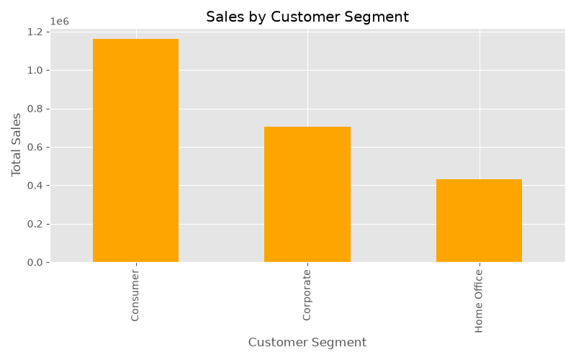
Figure 5: Sales by Customer Segment
Explanation:
This graph shows sales contribution from different customer segments and highlights the most valuable customer groups.
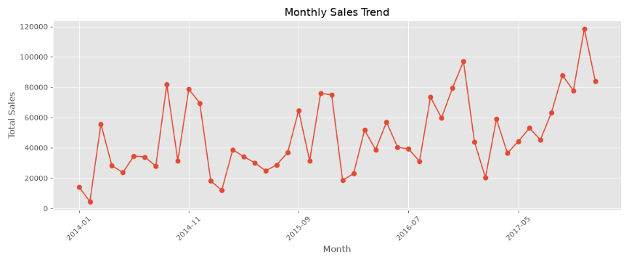
Figure 6: Monthly Sales Trend
Explanation:
This graph displays monthly sales patterns and helps identify seasonal trends and changes in demand.

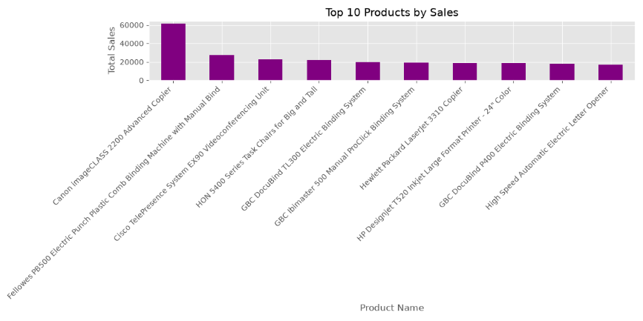
Figure 7: Top 10 Products by Sales
Explanation:
This graph highlights the products generating the highest sales and identifies the most popular items.
Data Visualizations (Part 4)
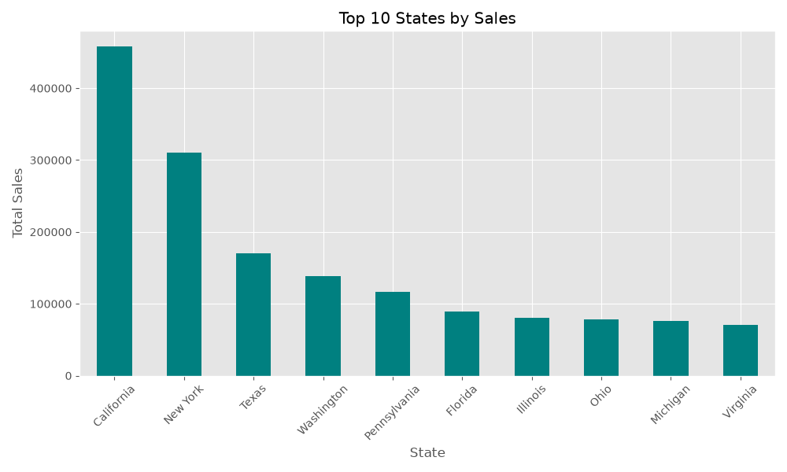
Figure 8: Top 10 States by Sales
Explanation:
This graph identifies the states contributing the highest sales and shows important markets.

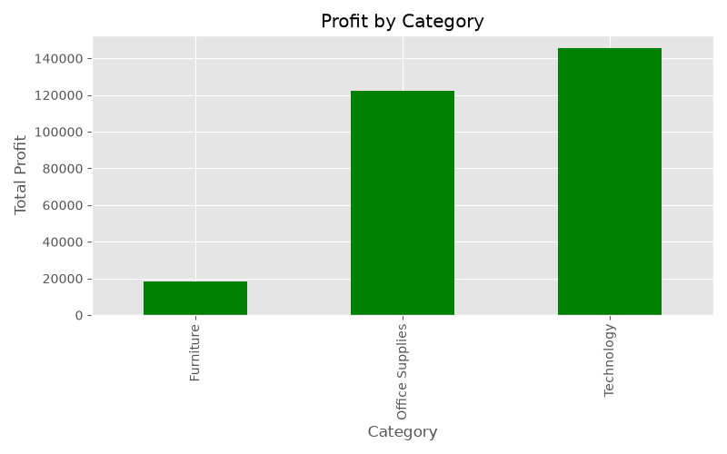
Figure 9: Profit Analysis by Category
Explanation:
This graph compares profits among categories and helps determine the most profitable product groups.

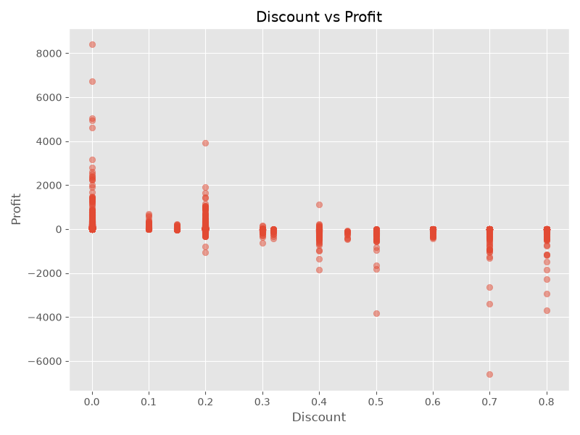
Figure 10: Relationship Between Discount and Profit
Explanation:
This graph shows how discounts affect profitability and helps understand the impact of pricing strategies.

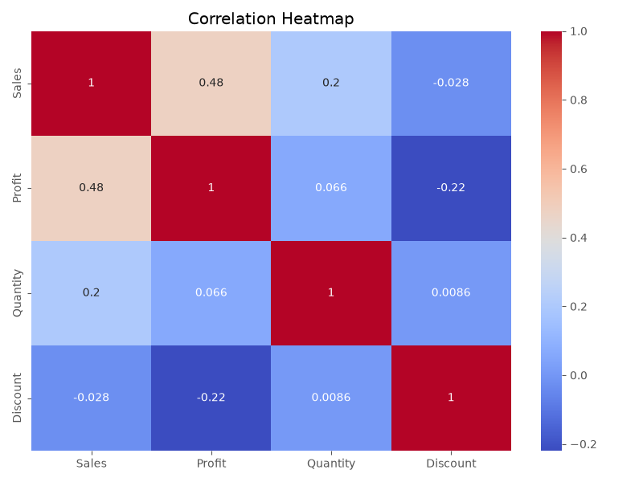
Figure 11: Correlation Between Numerical Variables
Explanation:
The heatmap shows relationships between variables and helps identify important patterns in the dataset.

Business Insights
- The analysis identified the highest-performing categories and regions contributing to sales.
- Customer segments with higher sales contribution were identified.
- Certain products generated significantly higher revenue compared to others.
- Discounts showed an impact on overall profitability.
- Sales trends helped identify patterns and seasonal variations.
Conclusion
This project provided practical experience in data cleaning, exploratory data analysis, and visualization. The insights obtained help understand sales performance, customer behavior, and factors affecting profitability.

References
- Dataset: Superstore Sales Dataset
- Tools Used: Python, Jupyter Notebook, Microsoft Excel
- Libraries Used: Pandas, NumPy, Matplotlib, Seaborn

